Welcome to WileyPLUS
WileyPLUS is an online teaching and learning environment that will help you reach your full potential in this course and beyond. You can access…
+ The complete online textbook! + Instant Feedback!
+ Extra study aids! + Track your own progress!
+ 24/7 accessibility! + Much, much, more…

Registration Code Savings!
You will need a registration code to access WileyPLUS. It’s your choice to buy it with or without the printed text:
- Use the online version of your text in WileyPLUS, go to:
www.wileyplus.com/buy and save!
- Buy the new, printed text in the bookstore and a WileyPLUS access code will be included. DO NOT THROW THIS AWAY!
Note: If you purchase a used book you’ll still need to buy a WileyPLUS code. The above options are the most cost efficient.

Getting Started - Course Finder

If you don’t have a class section URL, begin by navigating to www.wileyplus.com and click Get Started in the Students section of the homepage. The Course Finder page will display.

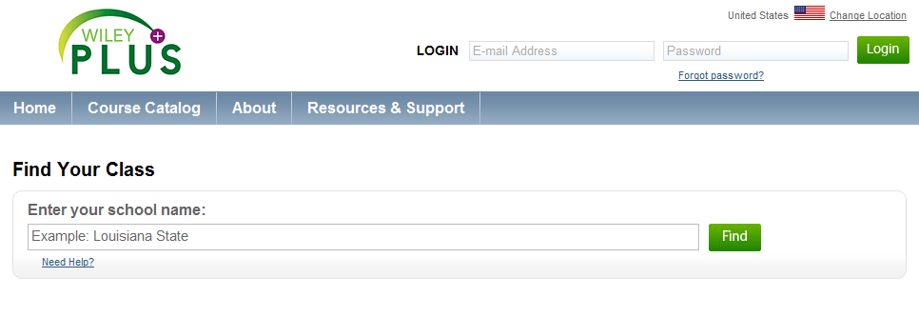
- Enter school name in the search field, click the name of your school when it appears and click Find.
- Here you have the ability to search for your class section by course or instructor
- Once you find your course in the list, click the Plus sign next to the course name. Next you’ll see a list of class section names, along with assigned instructors, terms, and meeting times.
- To choose the class that you would like to register for, click the green Select button.
- If you have used WileyPLUS before and already have an account, enter e-mail address and password and click log in. If you do not have a WileyPLUS account, click Create Account.
Login: www.wileyplus.com
LIVE CHAT! Technical Support: www.wileyplus.com/support
Additional Resources: www.wileyplus.com/studentfdoc

